



**SM6P07NI Digital Media Project**

**20% Research and Proposal**

**2018-19 Autumn**

**Student Name: Prabesh Maharjan**

**London Met ID: 22067396**

**College ID: NP01MM4A220081**

**External Supervisor: Sameer Maharjan**

**Internal Supervisor: Shruti Pradhan**

**Assignment Due Date: 2025/01/08**

**Assignment Submission Date: 2025/01/08**

**Word Count: 768**

*I confirm that I understand my coursework needs to be submitted online via Google Classroom under the relevant module page before the deadline in order for my assignment to be accepted and marked. I am fully aware that late submissions will be treated as non-submission and a marks of zero will be awarded.*

# Abstract

The project is going to be a TVC for a tea company, where the TVC is going to incorporate story and colours to convey a story to the audience. This TVC will show how a cup of tea can make your whole day colourful.

This document will have research materials, research reports, and planning required for the completion of this project.

# Contents

Abstract 2

Contents 3

Section A: Research 1

1 Introduction 1

2. Literature Review 2

2.1. Literature Review: The Psychological Effects of Colour in Advertising 2

2.2. Camera angles in filmmaking. 3

4.1. Rules and Techniques of Cinematography 6

4.2. The influence of Editing and Visual Strategies in Advertising. 8

2 Product Review 10

3 Summary and Conclusions 13

Section B: Project Proposal 14

1 Project Title 14

2 Research Question 15

3 Treatment 16

4 Resources 17

5 Contribution of Others 18

6 Evaluation & Testing 19

References 20

Appendix 21

**Table of figures**

Figure 1 Netflix logo 2

Figure 2 Cocacola logo 2

Figure 3 MC donalds logo 2

Figure 4 ECU 3

Figure 5 CU Form movie GetOut 3

Figure 6 Medium shot 4

Figure 7 Long shot 4

Figure 8 extreme long shot 4

Figure 9 High angle shot form stranger things 5

Figure 10 Low angle shot from dark knight 5

Figure 11 rule of thirds 6

Figure 12 leading line 6

Figure 13 low key lighting 7

Figure 14 high key lighting 7

Figure 15 Shutter rules 7

Figure 16 premiere pro 8

Figure 17 use of colour in LALA Land 8

Figure 18 Advertisement of Taj tea 10

Figure 19 instrument 11

Figure 20 another advertisement 12

# Section A: Research

## Introduction

A client-based project made to showcase the importance of tea in a person’s life. The purpose of this advertisement is to cinematically make a tv commercial different that other traditional commercial and make the brand help to stand out from the crowd.

This project will intertwine colours into the story to portray the happiness of a man and that happiness will be directly proportional to the tea which is the brand promotion we will be doing in the video. The happiness and the sad ness will be represented by colourful and black and white respectively. The story will progress with the use of colourful and non-colourful scene which will create a sense of importance of the tea in that man’s life.

For this project to be completed research in topics such as, camera angle, sound design, colour theory, etc should be carried out.

## Literature Review

### Literature Review: The Psychological Effects of Colour in Advertising

International Journal of Business and Social Science

Colour and Advertisement goes along so well people don’t even notice it most of the time. Colour and brand representation is massively important in this game of advertisement, fame and reach. According to the article “The Psychological Effect of Colour in Advertisement” Written by International Journal of Business and Social Science Colour plays a critical role in brand recognition, emotion and decision making. This study highlights that people process colour information before giving a glance towards other elements in the advertisement.

Brand Identity: This study shows that brands use the same colour in their logo, or the advertisement for a very long period to make a brand identity of the colour they use. For example, McDonalds uses yellow in their logo, mascot and advertisements and that sole yellow colour creates a brand identity. Same goes with other companies like Coca-Cola, Netflix, etc



Figure 1 Netflix logo

Figure 2 Cocacola logo

Figure 3 MC donalds logo

Emotion: This study shows that certain colour triggers certain emotion in the human mind, for example Red evokes, love, intimacy, urgency whereas company using green will most probably be related to nature, or eco-friendly stuffs. Whereas Purple is used by Luxury brands, Blue for trust and many more.

Impact on consumer decisions: This study shows that colours play a vital role in consumers decision as well. Since, people assign colours with emotions, people tend to buy green products if they want healthy stuffs, where as people will be attracted towards purple for its luxury.

Conclusion: From this article written about importance of colours in advertisement, we find out that people assign emotions to each colour and act accordingly to their emotions. In my Project I will be trying to use the same colour theory for better story telling in my advertisement.

### Camera angles in filmmaking.

Camera angles are an important aspect of visual storytelling, offering many ways to present characters, actions, and emotions. The article "[The Ultimate Guide to Camera Shots](https://www.studiobinder.com/blog/ultimate-guide-to-camera-shots/)” explores these techniques in depth. This review elaborates on the key angles, their uses, and their effects on audiences, integrating insights from other scholarly resources.

1. Extreme Close-Up (ECU)

An Extreme Close-Up Shot is a detail showing shot where the shot is either shot with telephoto lens or by taking the camera realty close to the subject or the object. In this shot, extreme details of a character are shown like the pupils of eyes, sweat in the face, etc.



Figure 4 ECU

2. Close-Up (CU)

A Close-up shot is also a tight show where the face of the character is shown to evoke personal and emotional connection between the views and the character. This shot also shows the detail and expression on the face.

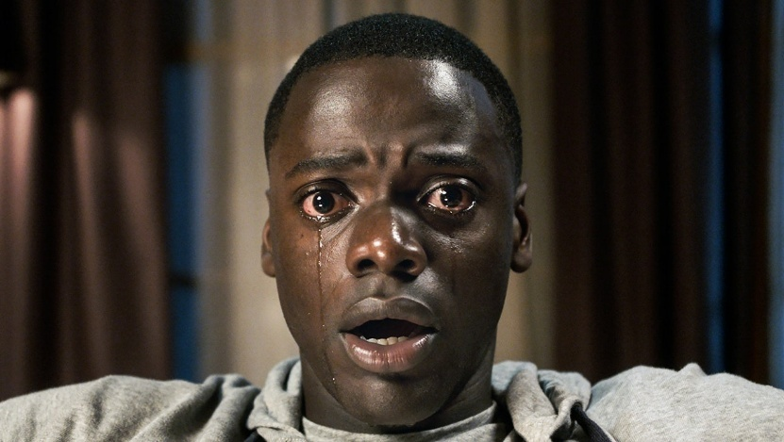

Figure 5 CU Form movie GetOut

1. Medium Shot (MS)

Medium shot is the shot where the character is frame from the waist above. It focuses on the body language and the background.



Figure 6 Medium shot

1. Long Shot (LS)

Long shot also know as wide shot is an establishing shot which establishes the narrative of the story in the beginning. Herr more of the environment is shown and the character is either absent or very small.



Figure 7 Long shot

5. Extreme Long Shot (ELS)

Extreme Long Shot is an exaggerated version of long shot where the character is shown even smaller of more dramatic effect.

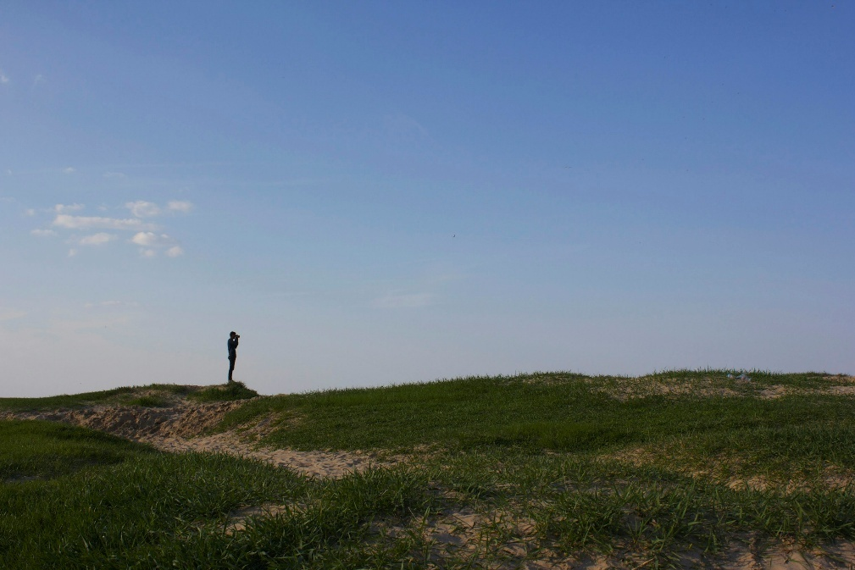

Figure 8 extreme long shot

6. High-Angle Shot

A high angle shot positions the camera above the subject, and the camera is locking down at the subject which will make the character look powerless. ​

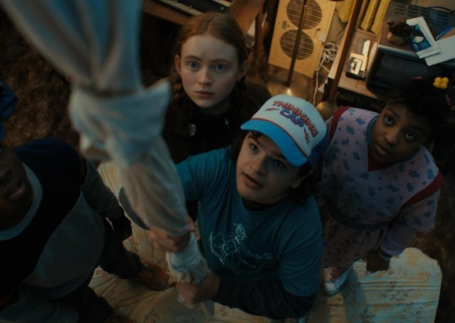

Figure 9 High angle shot form stranger things

7. Low-Angle Shot

Conversely, the low angle shot places the camera below the subject, looking up. This emphasizes the power level of the character in the frame.



Figure 10 Low angle shot from dark knight

Conclusion

The article by StudioBinder detailly explains the importance of camera angles in storytelling. Use of all these camera angle will further elevate the cinematic experience of our advertisement which we are making. The project will highly incorporate this camera angles to make the advertisement cinematic.

### Rules and Techniques of Cinematography

The article from the University of Pennsylvania explains the rule of cinematography to elevate the views experience and to properly tell a story. Rule of third and leading lines are two most important rule according to this article. Rule of third make 4 focusing point on a screen where the views attention is most and according to the rule of thirds, our subject should be place strategically in such points. Whereas leading lines are the focus pulling line in a screen which are more like to be architecture, like in the scene which pulls the eye to the subject, for example the road’s lines, architecture lines meeting into a point.

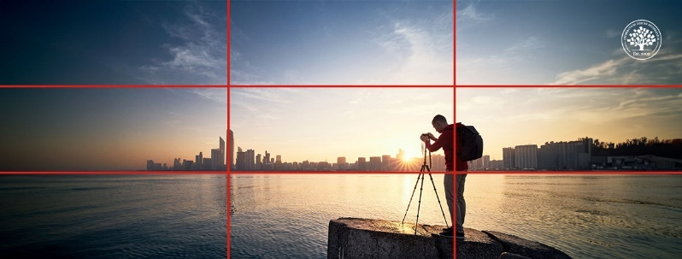

Figure 11 rule of thirds

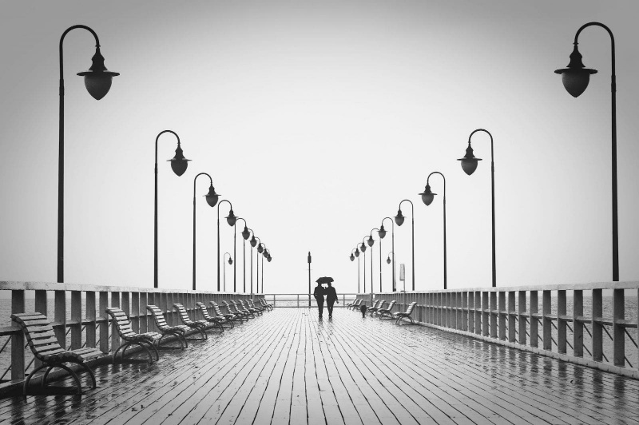

Figure 12 leading line

According to this article, Lighting techniques also plays a vital role in storytelling. High key lighting meaning lighting the scene comparatively bright with less contrast will make the scene happy and bright whereas, low key lighting where the light is little and the shadow part is more, will evoke a sad and dramatic feeling in the shot.

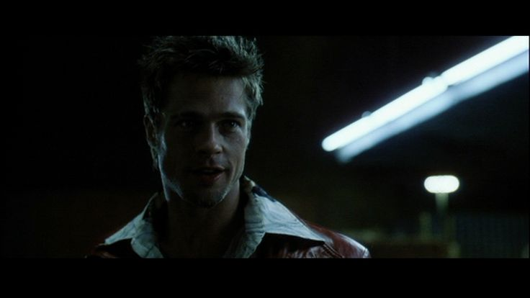

Figure 13 low key lighting

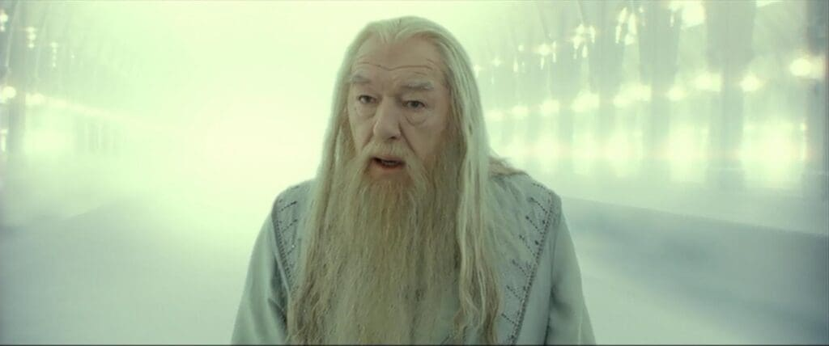

Figure 14 high key lighting

Other rules such as camera angles plays a vital role in storytelling and rule like the 180-degree shutter rule plays a very important role in filmmaking. As our human eyes captures motion blur almost like 1/50 shutter speed in 24 frames video. To keep the scene more appealing to human eyes, 180-degree shutter rule should be followed. But after learning all the rules, breaking the rules can make the scene even better if it is done right.

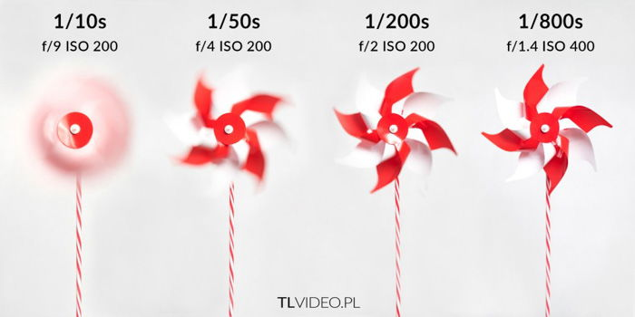

Figure 15 Shutter rules

In conclusion, the article teaches the rules of cinematography and tells us breaking the rules is another rule of the cinematography to standout form the crowd.

### The influence of Editing and Visual Strategies in Advertising.

This thesis paper explores the importance of editing and visual strategies for shaping an advertisement for the viewers consumption, brand identity, storytelling and advertisement effectiveness. This paper helps and guides people in creating visually pleasing advertisement.

**Editing techniques as a Narrative tool.**   
This thesis emphasizes on the importance of editing for crafting an advertisement’s narrative. Editing styles such as cross cutting, match cuts, jumps cuts, parallel editing, etc are analysed for the ability to create seamless transition’s that maintain viewer engagement. The pacing of the advertisement can be fast for the sense of urgency, or slow for the emotional connection with the viewers. These editing techniques are utilized to convey the advertisement message in a limited time.

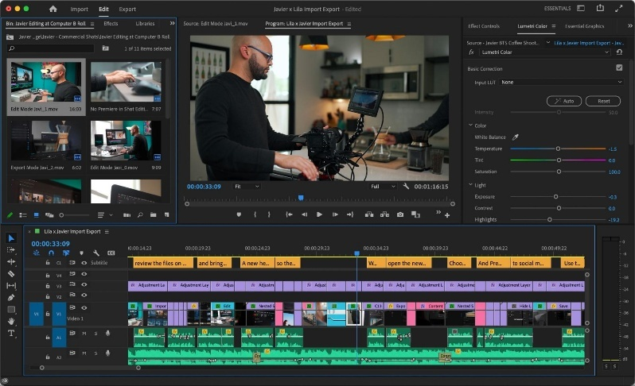

Figure 16 premiere pro

**The role of Visual Composition and Colour**  
The study studies the significance of colour scheme and their psychological effects ion views. Warm colours like red and yellow shows excitement and urgency whereas cool colour palates like blue convey trust and calmness. When a colour is extensively in focus for the advertisement it evokes a brand recognition. Furthermore, composition techniques and framing techniques such as close-ups are examined for there ability to create intimacy, whereas wide shots establish context.

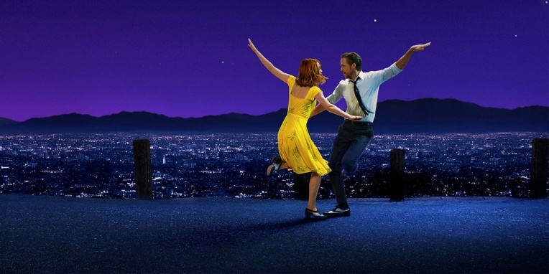

Figure 17 use of colour in LALA Land

**Psychological Effects and Views Engagement**This thesis also emphasises the psychological principles underlying effective advertisement. It describes how editing techniques create emotion by using time as an editing tool. For example, montages are often used to show positive progress, which shows a sense of achievement and accomplishment. It also shows the importance of music for the brand identity as well.

**Cross-Media Adaptibility**  
Another focus of this paper is the adaptability of editing techniques across different media platforms. Since the worlds is moving ahead with faster pace especially after the rise of internet and digital and social media, advertisement should have to be more modern to keep up with the time and to create reliability. For that reason, editors must be able to create advertisements in different aspect ratio such as vertical 1080, 4:3 ratio for nostalgic look, Wide screen ratios for cinematic look, etc.

**Conclusion:**This thesis gives beautiful insight about editing techniques for creating advertisement, connect with views in emotional level and how to keep up with the fast-pacing digital world. By understanding these principles, people can create beautiful advertisement with better visual storytelling and emotional connection with the viewers.

## Product Review

**Taj Mahal Tea - Wah Taj!**

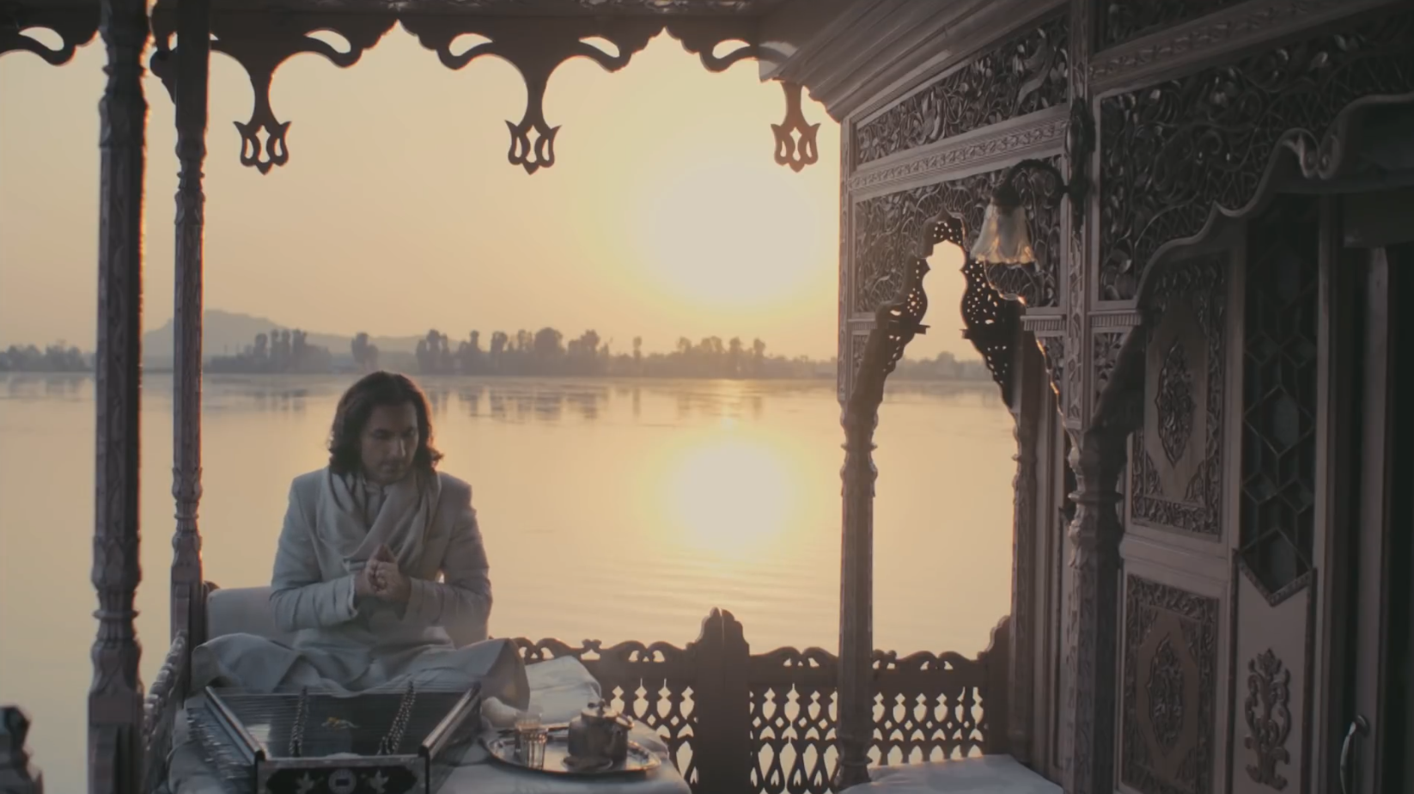

Figure 18 Advertisement of Taj tea

<https://www.youtube.com/watch?v=iDSoI-z6qaY>

This is a legendary advertisement of a Indian Tea Brand Taj Mahal Tea. This was one of the advertisements that I used to watch whenever I was watching something on the tv when I was little.

In this Advertisement there is a Artist on a boat with Santoor (An old Indian musical instrument with strings), and another boy on a boat says how to play that instrument, The actor starts to play a signature tune composed by Taufiq Qureshi. After he is done playing, the boy says wah hustaz wah, And the actor says wah Taj bolye , which is the iconic line of the Tea brand Taj Mahal Tea.



Figure 19 instrument

The Good:   
The visual art style of this ad is very good as, it used closeups for that intimate feeling of closeness.

The use of music and the musical instrument is phenomenal as it successfully gives the Indian feeling and the good and cosy feeling of togetherness.

The ending where the bosy says Wah hustaz wah, And the actor says wah Taj bolye, the clever incorporation of the brand slogan was very good and seamless.

The Bad:

The advertisement doesn’t really show of the tea.

Conclusion:

From this Legendary Advertisement, I learnt how a soundtrack can instantly show a brand identity, and a how a soundtrack can also create an emotional feeling of togetherness. I liked the use of closeup shots for the intimate and close feeling, which all the tea brands convey in their advertisement. I plan on using the idea of a beautiful sound track, the sue of closeup shots in my project.

**Tata Tea Agni - Josh Jagaye Har Roz | 90 SEC Hindi (Supers)**

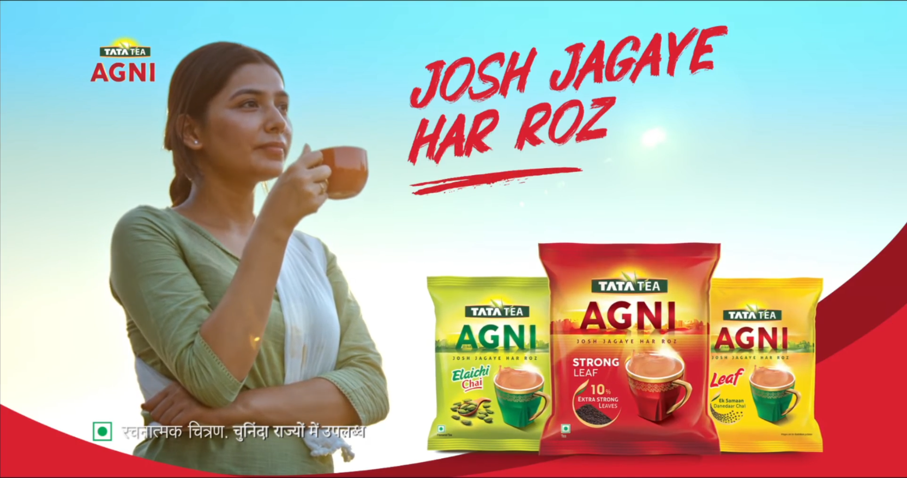

Figure 20 another advertisement

<https://www.youtube.com/watch?v=hsDvbi22hVk>

This an Advertisement of Tata Tea Agni. In this ad, the tea and the effort of a mom is intertwined for giving a message. The ad emphasises how a mom wakes up earlier that the sun, takes care of her whole family, not only makes tea, but makes a cricketer, superstar, doctor and many more. How she need energy for her daily activity and her perfect partner is Tata Tea Agni for keeping the energy witing her.

**The Good:**   
The storytelling is jut perfect in this advertisement.

Incorporating the brand in different part of the video was perfect well.

Showing stories of different moms of her handling her household like a montage was pretty good.

**The Bad:**

The ad could have used better camera techniques and lighting for better visuals.

**Conclusion:**

From this advertisement I will incorporate the story telling in my Advertisement, And the use of the tea in between the regular lives, making it more natural and less of an obvious advertisement. I will be using the montage like editing for my advertisement as well for showing progress.

## Summary and Conclusions

From this research, we get to know the physiological effect of an advertisement because of the colours used in it, sound used in it, storytelling and more. For example, in colour psychology, red invokes urgency ore intimacy whereas nature and health. Colour not only invokes feelings but repeatedly using of a certain colour will give it a brand identity just like Coca-Cola, Fanta, etc.

Just like Colours, cinematography techniques can also be used to present different feelings such as, extreme close-up for intimacy or showing details, low angle for dominance and montages to show progress and emotion. Furthermore, the pacing, transitions also play a vital role in connecting to a certain generation of people as older people might not find new editing styles fun or appealing.

Since the project is mainly driven by colours, the colour theory will be used at most, and since this project will be visualizing around black and white to colourful, use of old school music like orchestra, violin will be utilized to give it an old taste and use of modern music for the transition.

# Section B: Project Proposal

## Project Title

A Cup of Colours.

This project is going to about how a cup of tea can colour your whole day and make it happy. This advertisement is going to show how colour and happiness are intertwined together.

## Research Question

How can we break the rules of traditional TVCs and incorporate cinematic art and emotions into TVCs?

I plan on breaking the traditional TVC rules and incorporating cinematic art and emotions into TVC that I am creating by utilizing the modern trends, use of colour and proper sound designing. Since the project is going to revolve around how a tea can light up someone day, which will be portrayed by the spread of colours throughout his whole day, I will be using the black and white and colourful elements into consideration and revolve around that topic for creating emotional connection and the meaning of the whole TVC. Traditional TVC’s have only used colours to emphasize a feeling like Coca-Cola using red to promote its brand value and intimate relation with partners sharing a moment together. But in my project, I will be utilizing all the million and billions of colours that our eyes can read and making them present and absent to show the meaning of the TVC.

## Treatment

The commercial begins in black-and-white, showing a monotonous day in the life of the protagonist. Upon drinking tea, colors start spreading, symbolizing the energy and warmth that tea brings. As the tea runs out, the colors fade, only to return when new tea leaves are delivered. This narrative highlights the transformative power of tea and its role in uplifting daily life.

## Resources

Hardware:

* Mid-range camera that can at least shoot 4:2:2 10-bit colours (sony a6700)
* Gimble preferably dji rs4.
* Wide arsenal of lens. (Tamron 17-70 f 2.8, Viltrox 85mm f1.8, TTArtison 7.5 mm f2 fisheye lens)
* Drone
* Lighting equipment (bi colour cob light, full srgb Led light)
* High Performance Laptop.

Software:

* Davinchi resolve for video editing.
* Lightroom classic for photo editing.
* Photoshop for graphic designing and poster making.
* After effect for motion graphics or advance editing.
* Reason 12 for making soundtrack.

## Contribution of Others

**Client’s Role:** Provide input on the brand’s message, approve drafts, and supply branding materials (e.g., logo, tagline).

**My Role:** Oversee creative direction, videography, editing, and post-production. Coordinate feedback and ensure timely delivery.

**Others:**

Cast for this project will be Rahul Darshan.   
Other people will be helping on set for lighting, sound and many more,  
Roman, Ranjan, Anush, Akash, Sudarsan, Ayusha, Asuka, etc.

## Evaluation & Testing

Evaluation and Testing can be done in various ways such as:

One to one:

In this method where a viewer is asked questions such as feedback, good thing and bad thing, area of improvement directly at the premiere of this advertisement. This will be conducted main for the first viewers like the client itself, teachers, and people close to the project.

Forms:

For the viewers whom we can’t meet personally we will make a google forms and ask questions there. Google forms makes this process very easy as we can simply create question and option the share the link and people can fill up this survey with ease.

# References

Jura, B. (2020). *How to Use Color Psychology in Marketing*. [online] American Marketing Association. Available at: <https://www.ama.org/marketing-news/how-to-use-color-psychology-in-marketing/>.

‌StudioBinder (2024). *50+ Types of Camera Shots & Angles*. [online] StudioBinder. Available at: <https://www.studiobinder.com/blog/ultimate-guide-to-camera-shots/>.

‌STEVEN J. ANDREWS (2011). *VISUAL RHETORIC IN ADVERTISING: HOW CONSUMERS COPE WITH A PLEASANT EXPERIENCE*. Available at: <https://scholarsbank.uoregon.edu/server/api/core/bitstreams/200ef227-606c-4227-8851-cea0db9369a0/content>

Taj Mahal Tea (2015). *Taj Mahal Tea - Wah Taj!* [online] YouTube. Available at: <https://www.youtube.com/watch?v=iDSoI-z6qaY> [Accessed 8 Jan. 2025].

Tata Tea Agni (2024). *Tata Tea Agni - Josh Jagaye Har Roz | 90 SEC Hindi (Supers)*. [online] YouTube. Available at: <https://www.youtube.com/watch?v=hsDvbi22hVk> [Accessed 8 Jan. 2025].

‌

‌

‌

# Appendix

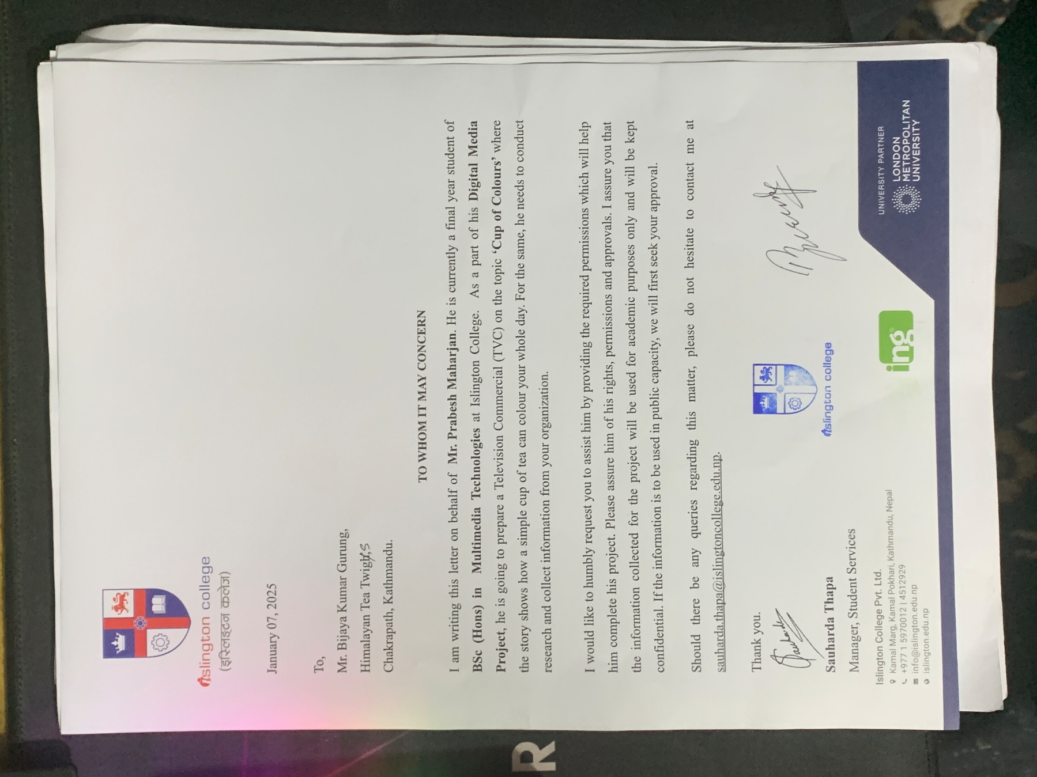

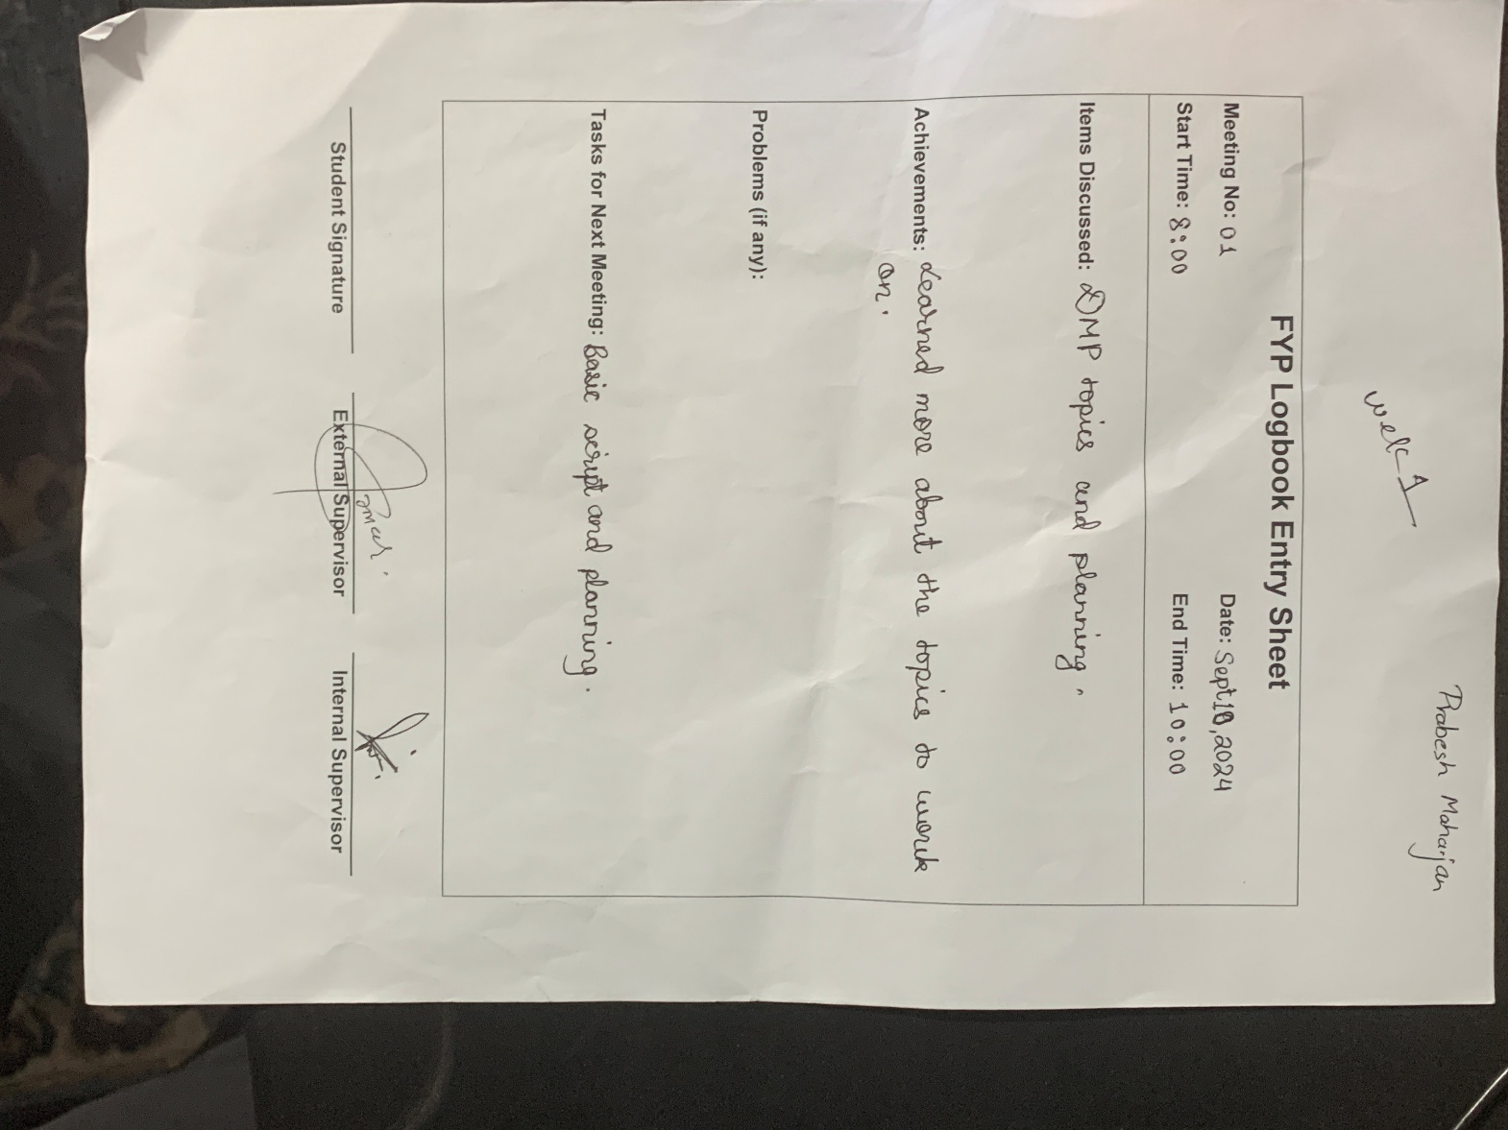

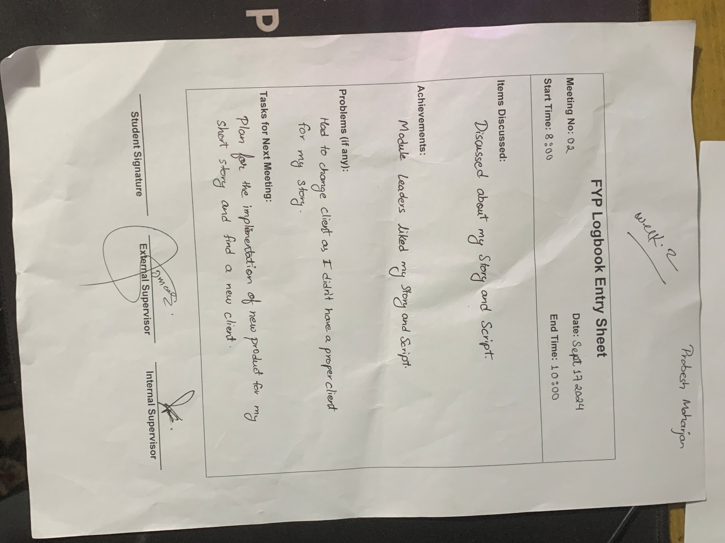

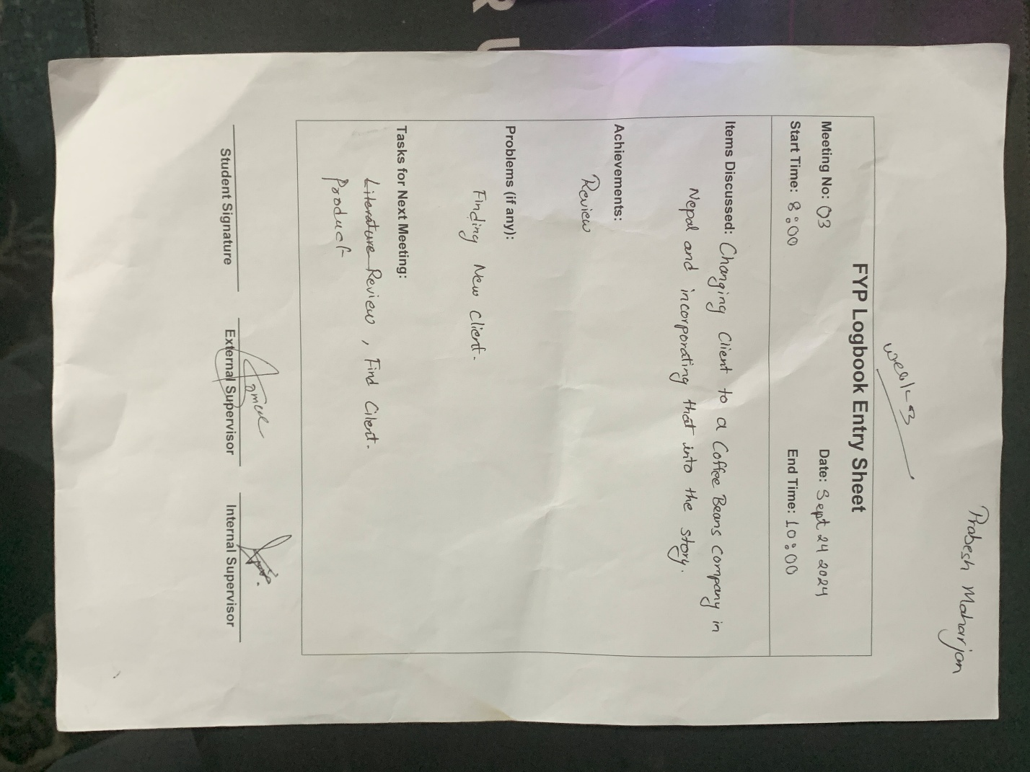

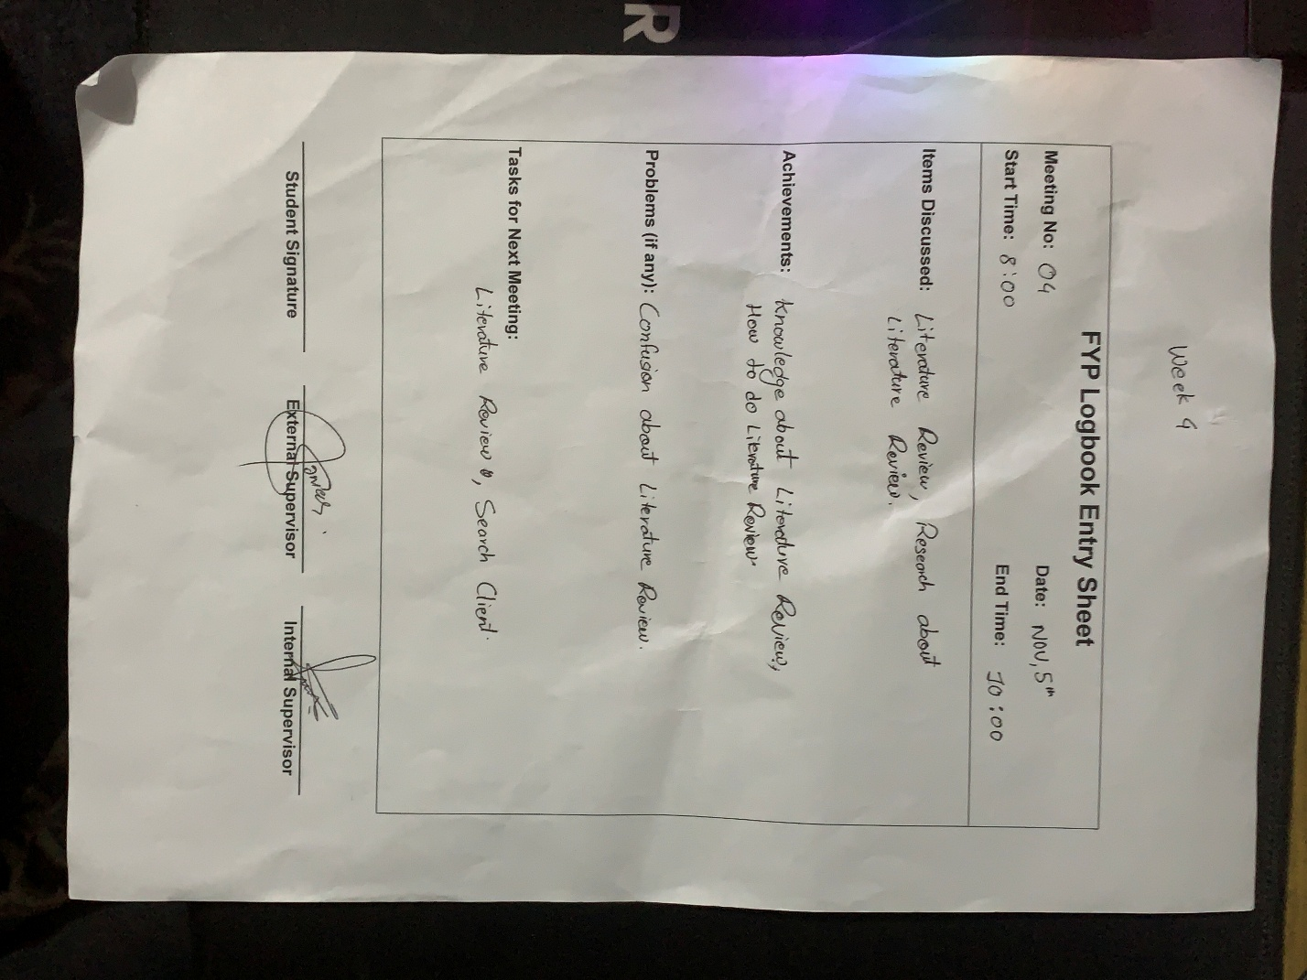

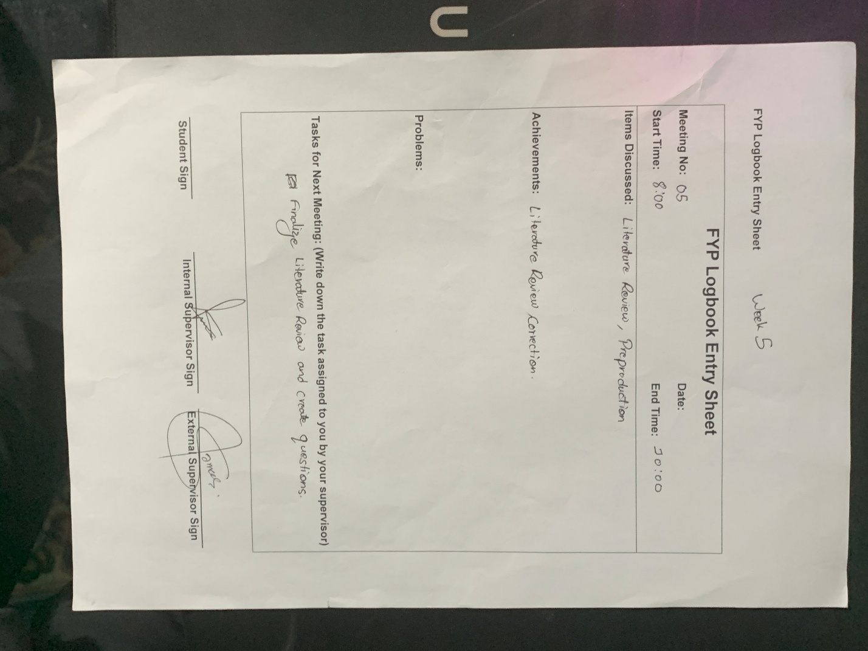

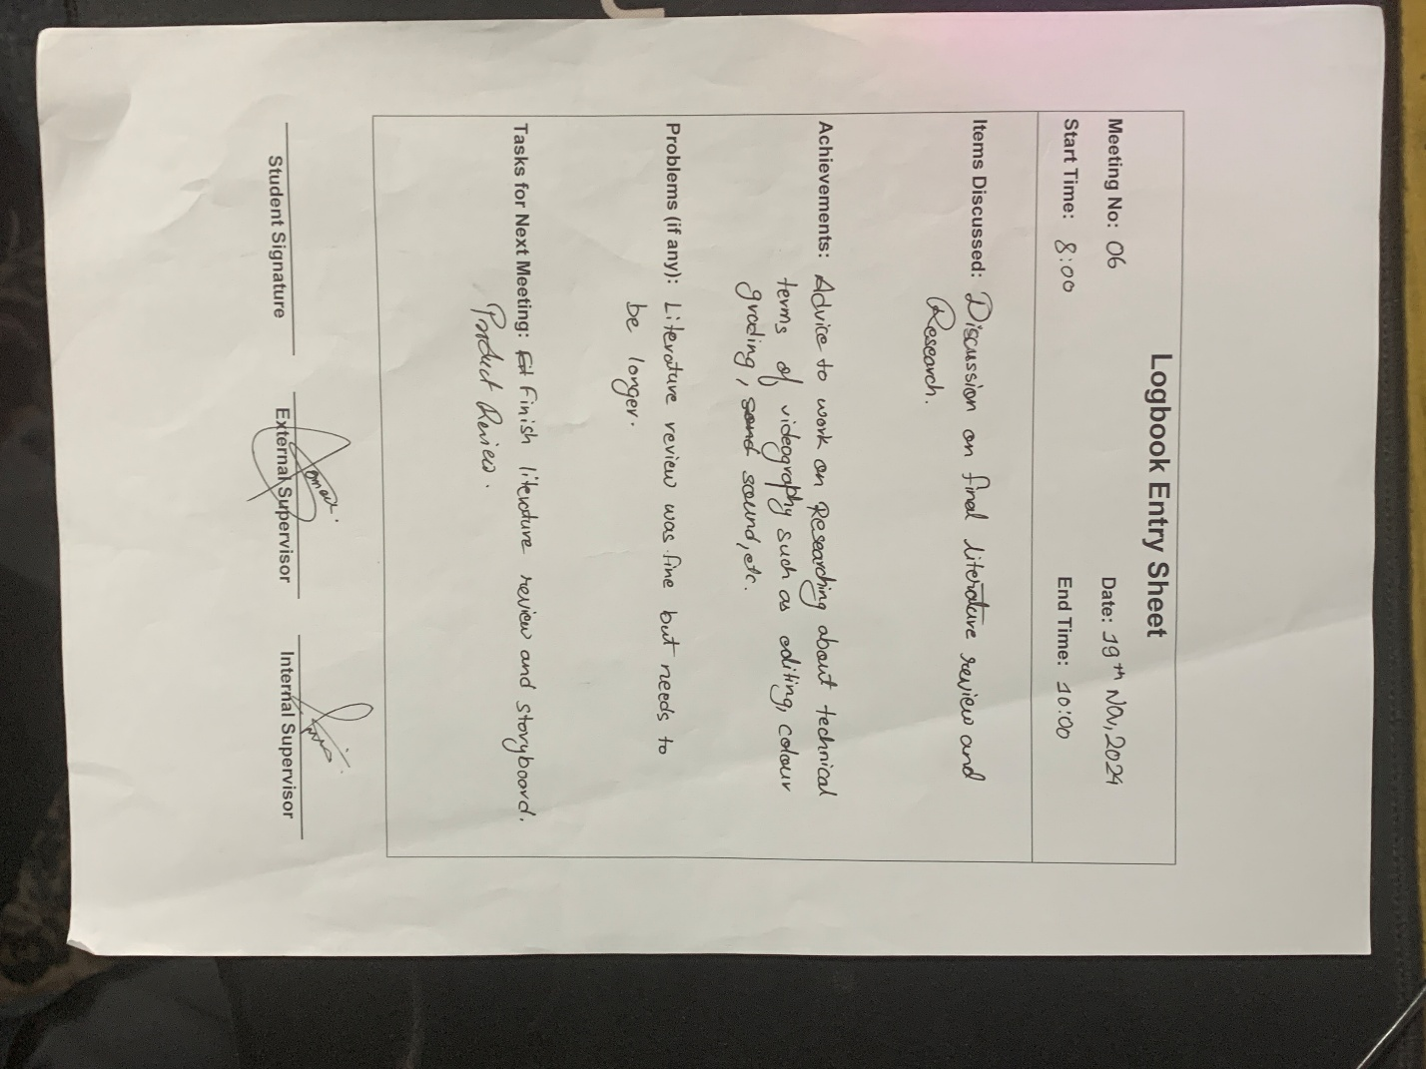

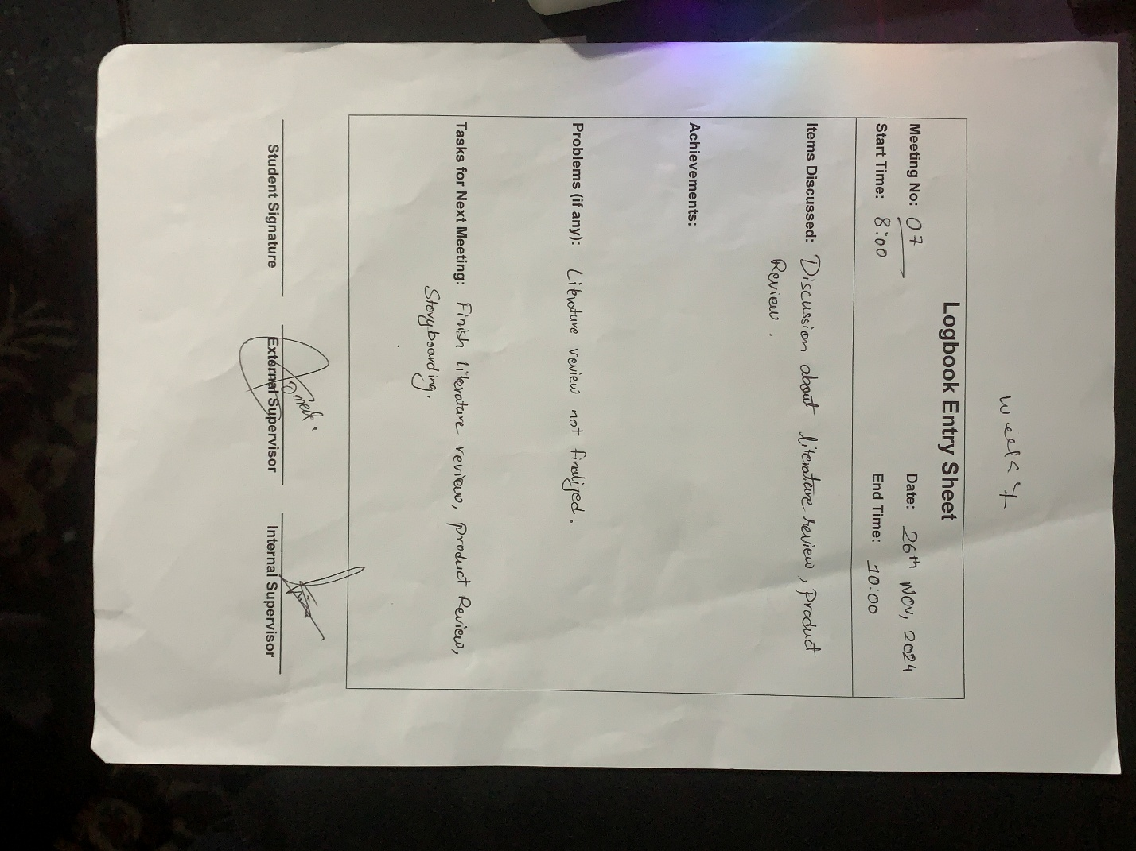

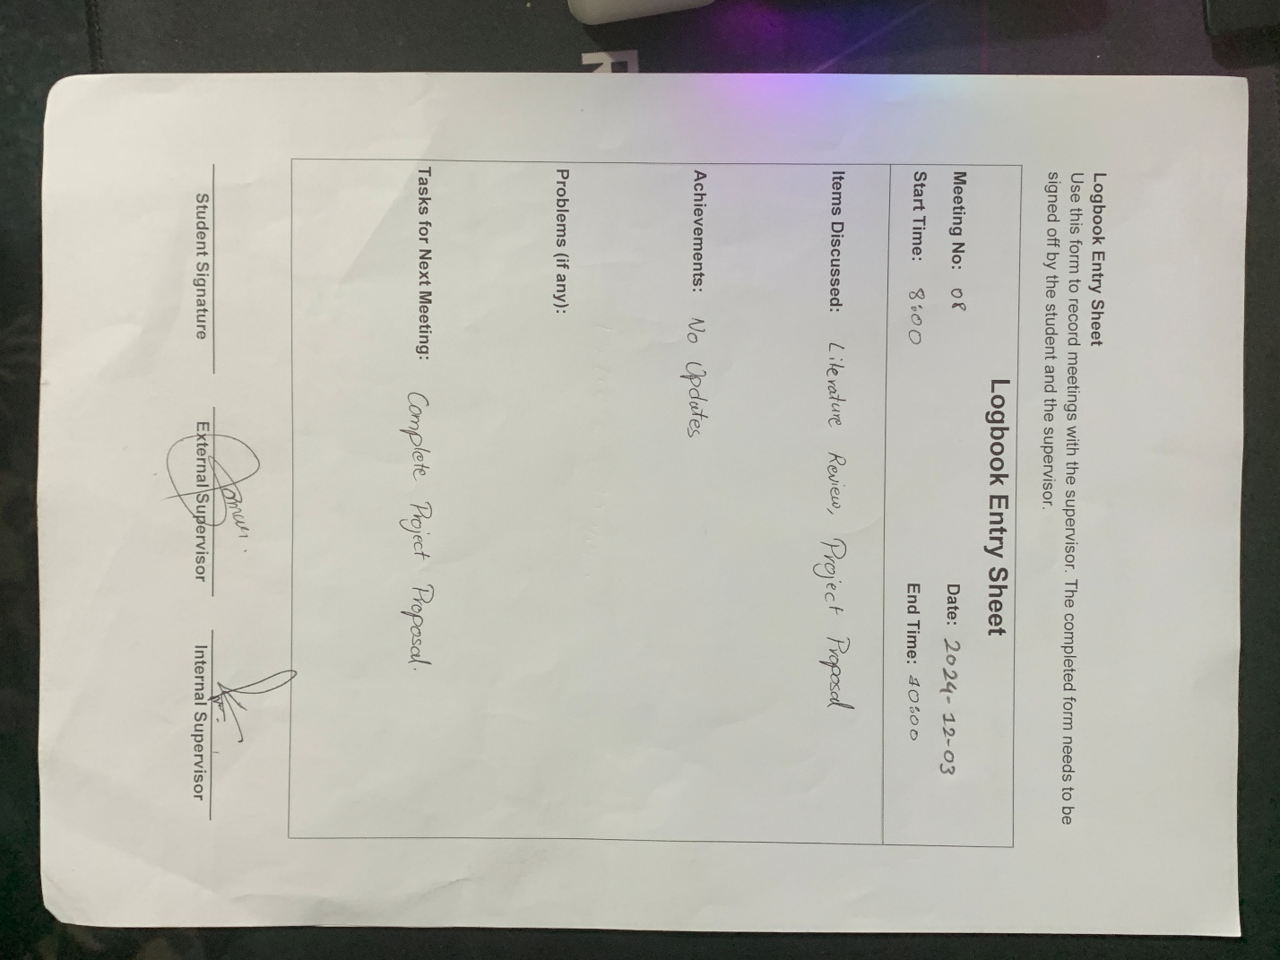

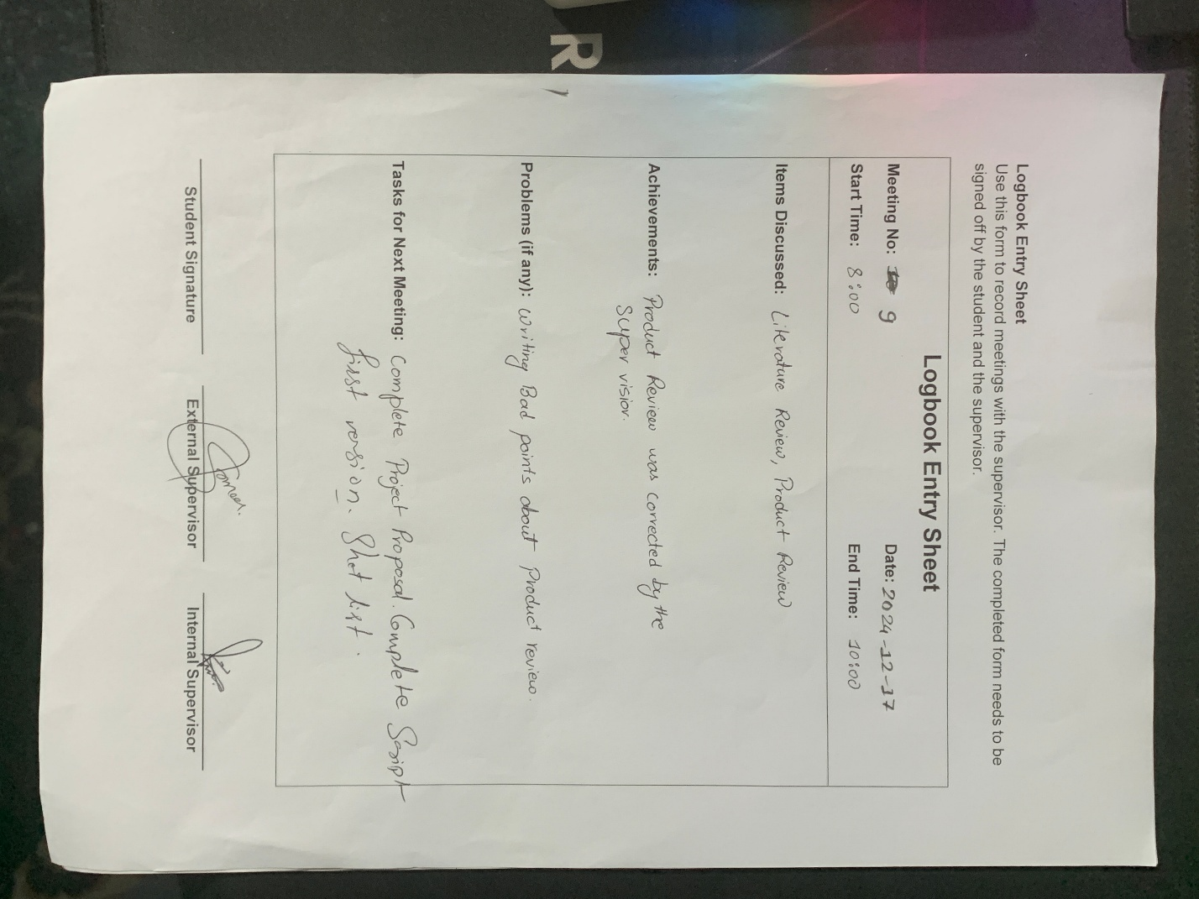

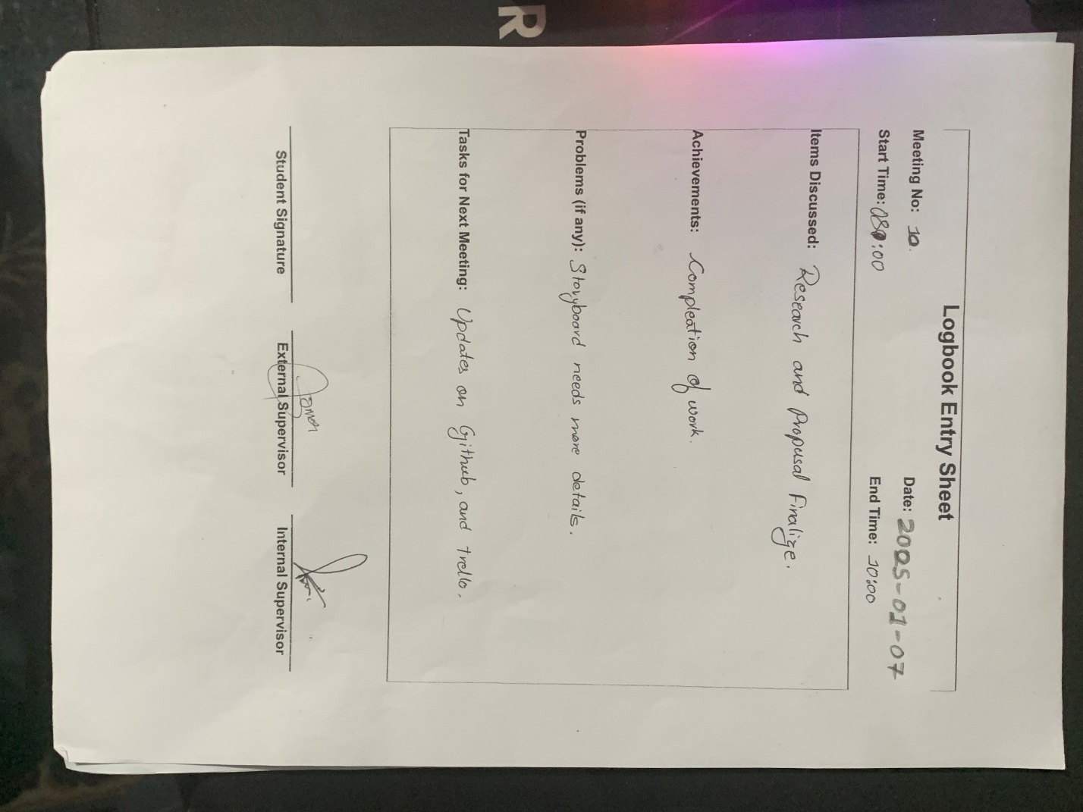

Story board:

|  |
| --- |
| Scene 1 |
|  |
| Opening Scene:  Top-down shot of Rahul sleeping and waking up after alarm. Everything is black and white.  Still shot, wide angle. |

|  |
| --- |
| Scene 2 |
|  |
| Close up shot of Rahul brushing.  Still shot close up  Sound of Brushing teeth. |

|  |
| --- |
| Scene 3 |
|  |
| Close up shot of Rahul bathing.  High angle shot, |

|  |
| --- |
| Scene 4 |
|  |
| Close up shot of Rahul making a cup of tea. The cup and the tea is colourful. |

|  |
| --- |
| Scene 5 |
|  |
| Wide shot of Rahul going for a jog. He is colourful whereas the environment isn’t. |

|  |
| --- |
| Scene 6 |
|  |
| Tight shot of Rahul going for a jog. He is colourful whereas the environment isn’t. |

|  |
| --- |
| Scene 7 |
|  |
| Wide drone shot of Rahul diving into the water, and he is releasing colours into the environment in a wave. |

|  |
| --- |
| Scene 8 |
|  |
| Medium shot of Rahul working in the computer. |

|  |
| --- |
| Scene 9 |
|  |
| Rahul goes back to sleep. |

|  |
| --- |
| Scene 10 |
|  |
| Rahul wakes up and repeats his daily activities. |

|  |
| --- |
| Scene 11 |
|  |
| Close up shot of Rahul brushing. |

|  |
| --- |
| Scene 12 |
|  |
| Close up shot of Rahul bathing. |

|  |
| --- |
| Scene 13 |
|  |
| Close up shot of Rahul making a cup of tea. He notices the tea leaves are getting finished. The cup and the tea is less colourful. |

|  |
| --- |
| Scene 14 |
|  |
| Wide shot of Rahul going for a jog. He doesn’t have the same energy as his previous day. |

|  |
| --- |
| Scene 15 |
|  |
| Drone shot of Rahul floating in the pool. |

|  |
| --- |
| Scene 16 |
|  |
| Medium shot of Rahul jogging back to his house. |

|  |
| --- |
| Scene 17 |
|  |
| Medium shot of Rahul working in the computer. But he isn’t efficient as his previous day. |

|  |
| --- |
| Scene 18 |
|  |
| Rahul goes back to sleep. |

|  |
| --- |
| Scene 19 |
|  |
| Rahul wakes up and repeats his daily activities. |

|  |
| --- |
| Scene 20 |
|  |
| Close up shot of toothbrush and toothpaste. Even the tooth paste is finishing. |

–

|  |
| --- |
| Scene 21 |
|  |
| Close up shot of Rahul making a cup of tea. But there is no more tea, hence nothing is colourful anymore. |

|  |
| --- |
| Scene 22 |
|  |
| Wide shot of Rahul going for a jog. But he doesn’t want to. |

|  |
| --- |
| Scene 23 |
|  |
| Rahul is doing nothing except sitting on the side of the pool. |

|  |
| --- |
| Scene 24 |
|  |
| Medium shot of Rahul not working in the computer. |

|  |
| --- |
| Scene 25 |
|  |
| Delivery of the tea is done and everything back to colourful for Rahul. |